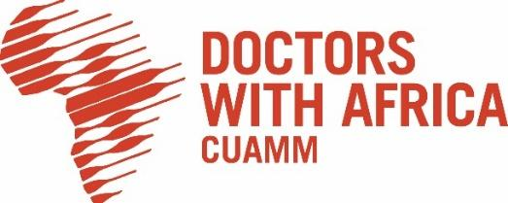

BID CANCELLATION NOTICE

Published on: May 12, 2026

Doctors with Africa CUAMM hereby informs all bidders that participated in the procurement procedure for the Supply of Medical Gases Supply Upgrading Works for Black Lion (Tikur Anbessa) Specialized Hospital Neonatal Intensive Care Unit (NICU) that was launched under the project titled: "Strengthening Neonatology in Ethiopia – AID 012958/ETH", with Tender No. 15/CUAMM/ETH/2026/AID 012958, and bid submission deadline of 12 June 2026, that the above-mentioned procedure has been cancelled.
The procurement has been cancelled because all the financial offers received exceeded the available budget for the contract.
Doctors with Africa CUAMM thanks all participating bidders for their interest and regrets any inconvenience caused.
Doctors with Africa CUAMM

