ANNEXII+III: TECHNICALSPECIFICATIONS+TECHNICALOFFER

Contract title: Supply of Medical Biomedical equipment and Medical Consumables p1/…
Publication reference: 07/CUAMM/ETH/2025/AID 05/12282/ETH

Annex III - the contractor's technical offer
The tenderers are requested to complete the template on the next pages:
- Columns 1 and 2 are completed by the contracting authority show the required specifications (not to be modified by the tenderer),
- Column 3 is to be filled in by the tenderer and must detail what is offered (for example the words ‘compliant’ or ‘yes’ are not sufficient),
- Column 4 allows the tenderer to make comments on its proposed supply and to make eventual references to the documentation.
The eventual documentation supplied should clearly indicate highlight, mark) the models offered and the options included, if any, so that the evaluators can see the exact configuration. Offers that do not permit to identify precisely the model sand the specifications may be rejected by the evaluation committee.
The offer must be clear enough to allow the evaluators to make an easy comparison between the requested specifications and the offered specifications.

LOT 1–Biomedical Equipment
1.  Item number | 2.  Specifications required | 3.  Specifications offered  TO BE FILLED BY THE SUPPLIER | 4.  Notes, remarks, ref. to documentation | 5.  Evaluation committee’s notes
1 | Electrical Safety Analyzer or similar circuit  Specifications: Rigel 288+ electrical Safety analyser:  Click here Rigel 288+.  This device is primarily used for IEC 60335 electrical safety tests, including:  - Protective earth continuity test  - Insulation resistance test  - Earth leakage current test  - Enclosure leakage current test  - Patient leakage current test  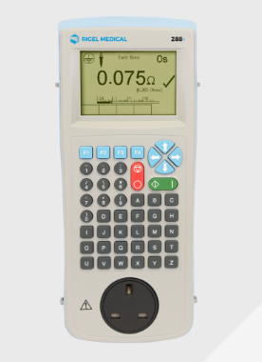  Refer to the following link:  (https://www.rigelmedical.com/gb/products/electrical-safety-testing/electrical-safety-analyzers/406a913-288-plus/)  Unit: each  Quantity: 1  Expires N/A  Delivery: CUAMM Addis Ababa | Specification offered:  Unit:  Expires Date:  Delivery time: (TO BE FILLED)
2 | O2 concentrator analyzer (Testing Equipment)  Specifications: Ultramax Oxygen Analyser  Click here UltraMaxO2 analyser  This device is primarily used to measure the oxygen flow and pressure.  It has integrated oxygen sensor, it can perform self-diagnosis and it includes silicone cover and silicone tube.  It can operate under the range 0LPM to 10LPM of oxygen flow.  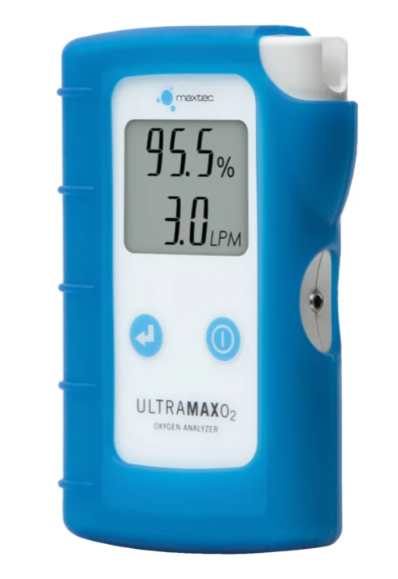  Refer to the following link  (https://drivedevilbiss.com/en/products/respiratory/oxygen-therapy/productdetail/ultramax-o2#tabBtn-description)  Unit: each  Quantity: 1  Expires N/A  Delivery: CUAMM Addis Ababa | pecification offered:  Unit:  Expires Date:  Delivery time: (TO BE FILLED)

Lot 2 Medical Consumables

1.  Item number | 2.  Specifications required | 3.  Specifications offered  TO BE FILLED BY THE SUPPLIER | 4.  Notes, remarks, ref. to documentation | 5.  Evaluation committee’s notes
 | Vaseline  Specifications: 300 ml  Unit: each  Quantity: 5  Expires N/A  Delivery: CUAMM Addis Ababa | Specification offered:  Unit:  Expires Date:  Delivery time: (TO BE FILLED)
 | Lubricants WD40  Specifications: 4 liter  Unit: each  Quantity: 1  Expires N/A  Delivery: CUAMM Addis Ababa | specification offered:  Unit:  Expires Date:  Delivery time: (TO BE FILLED)
 | Insulation tape  Specifications: 19mm x 20m  Unit: Pack of 24 rolls  Quantity: 1  Expires N/A  Delivery: CUAMM Addis Ababa | specification offered:  Unit:  Expires Date:  Delivery time: (TO BE FILLED)
 | Cable ties  Specifications: Nylon Patch 150X3.6 mm  Unit: package of 100  Quantity: 5  Expires N/A  Delivery: CUAMM Addis Ababa | specification offered:  Unit:  Expires Date:  Delivery time: (TO BE FILLED)
 | Silicone glue  Specifications:100 ml  Unit: box of 12  Quantity: 1  Expires N/A  Delivery: CUAMM Addis Ababa | specification offered:  Unit:  Expires Date:  Delivery time: (TO BE FILLED)
 | Teflon tape  Specifications: 12 inch  Unit: box of 10 Rolls  Quantity: 2  Expires N/A  Delivery: CUAMM Addis Ababa | specification offered:  Unit:  Expires Date:  Delivery time: (TO BE FILLED)
 | Solder wire  Specifications:  0.031"/0.8mm 454g  Unit: each/roll  Quantity: 1  Expires N/A  Delivery: CUAMM Addis Ababa | specification offered:  Unit:  Expires Date:  Delivery time: (TO BE FILLED)
 | Stick hot glue  Specifications: 50 pcs 7mm x 100mm H  Unit: each  Quantity: 50  Expires N/A  Delivery: CUAMM Addis Ababa | specification offered:  Unit:  Expires Date:  Delivery time: (TO BE FILLED)
 | Syringes  Specifications:50 ml  Unit: each  Quantity: 5  Expires N/A  Delivery: CUAMM Addis Ababa | specification offered:  Unit:  Expires Date:  Delivery time: (TO BE FILLED)
 | Hand sanitatiser  Specifications:1 liter  Unit: each  Quantity: 10  Expires N/A  Delivery: CUAMM Addis Ababa | specification offered:  Unit:  Expires Date:  Delivery time: (TO BE FILLED)
 | Alcohol-based cleaning solution  Specifications:1 liter  Unit: each  Quantity: 5  Expires N/A  Delivery: CUAMM Addis Ababa | specification offered:  Unit:  Expires Date:  Delivery time: (TO BE FILLED)

