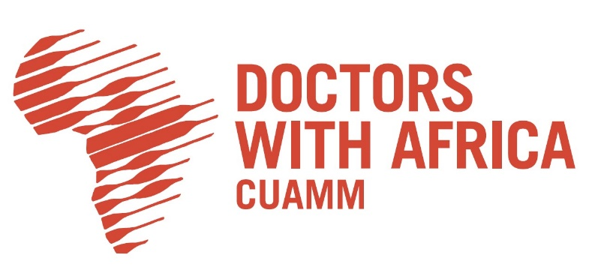
Addis Ababa, 30th of August 2022

TENDER ANNOUNCEMENT
Ref. Nr.: 16/CUAMM/ETH/2022

Subject: Supply of Printing Material and Office Stationary
The NGO Doctors with Africa CUAMM, under its projects implementation in different Ethiopian Regions, is launching the present Local Open Procedure to select eligible suppliers for Printing Press Material and Office Stationary.

Within the next 12 months, Doctors with Africa CUAMM is planning to procure Printing Press Material and Office Stationary for an amount of approximately 7.000.000 ETB (seven million ETB) both from Authorized Distributers and from Pharmaceutical Suppliers.

The tender is divided into two LOTS as follow:
LOT 1: Selection of eligible Printing Press Material Suppliers
LOT2: Selection of eligible Office Stationary Suppliers

The complete tender dossier is available at Doctors with Africa CUAMM main office in Addis Ababa during working hours (09:00-17:00) at the following address:
Bole Subcity, Woreda 3, house nr. 2434, Addis Ababa;
Simultaneously, it can be downloaded on Doctors with Africa CUAMM website at the following link:

….

The tender dossier includes:
- Instructions to tenderers and Contract notice
- Contract form including annexes
- Draft contract
- Annex II + III: technical specifications + technical offer
- Annex V: forms
- Further information
- Administrative compliance grid
- Evaluation grid
- Tender form for a supply contract and Declaration on honour on exclusion and selection criteria (annex A14a)

For full information about procurement procedures please consult the practical guide and its annexes, which can be downloaded from the following web page: http://ec.europa.eu/europeaid/prag/document.do

The deadline to submit the tender is fixed on 31/09/2022 at 5:00 PM.

Please send it to the address and with the requirements given in point 7 of the Instruction to Tenderers.

Yours sincerely

